## Usage Report

Key Details:

Programming language - Python

Version - 3.6.3

‘Web_server.py’ port number - 8000

‘Application_server.py’ port number - 8080

To run the Naughts and Crosses web application follow these step in order:

1. Open ‘web_server.py’ and ‘application_server.py’.
2. Run both files.
3. Open web browser and enter ‘<http://localhost:8000/game.html>’
4. The Naughts and Crosses screen should load and you are now ready to play the game.
5. To enter our choice, type a number in the text box and press submit

## Test Report

The state of the game board is maintained cross the moves and is rendered correctly as can see from the screenshots above.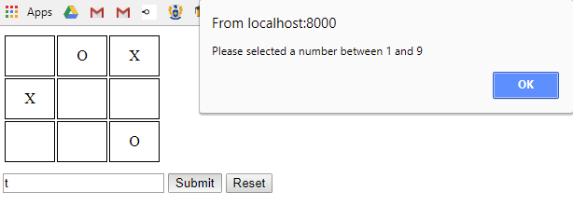

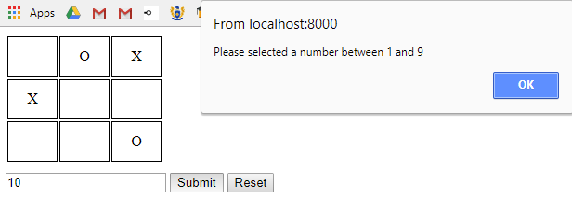

Correct game logic is maintained. When an invalid character is submitted the system handles the error correctly, letting the user understand that it is an invalid input. This can be seen in the two screenshots above.

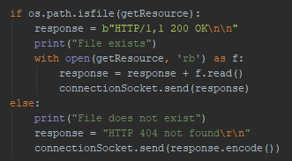

The system implements basic HTTP error handling of a age not found. This can be seen from the screenshot above.